BRADSHAW DANCE AND CHEER
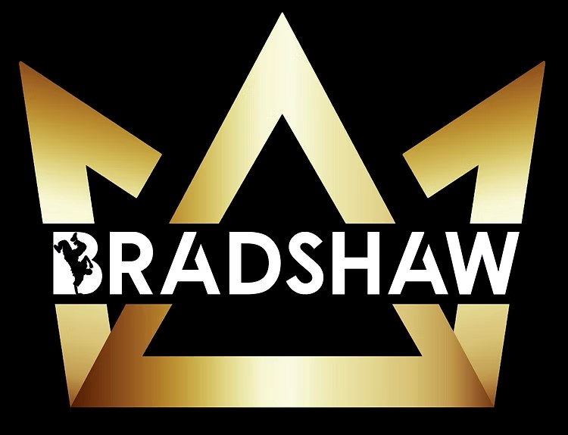

Complaints and
allegations record form

This form should be used to record a suspicion, allegation or disclosure of child abuse, or a complaint of unacceptable behaviour.

Your name and position
Name of the child or young person involved
Name of person
making complaint
Name of person who the complaint was made against

- Nature of the complaint: include time, date, location, what happened and who was involved (this can include observations of the child’s behaviour).

- Details of any injuries and if the child received medical attention.

- Accurately record what the child said when describing what happened – use their exact words –
or record why you suspect abuse due to an indirect disclosure, such as a drawing or observed behaviour.
(In the case of an allegation of abuse, formal investigations and interviews will be carried out by DCJ and/or NSW Police. You must record what the child has said but unless it is your role to investigate, you should not interview the child.)

- Details of anyone who saw what happened.

- Does this complaint indicate the possibility of child abuse, such as physical abuse, psychological or emotional abuse, sexual abuse or neglect?
Yes No

- Who did you make a report to?
NSW Police
DCJ via ChildStory
DCJ via 132 111
OCG Reportable Conduct Directorate
Internal reporting obligations (name the relevant department or person)
Other (name them)

- People spoken to in relation to the matter (describe who was spoken to and why they were spoken to about the matter – include police officers, DCJ staff, OCG staff and anyone else you spoke to).

Date(s):

