BRADSHAW DANCE AND CHEER
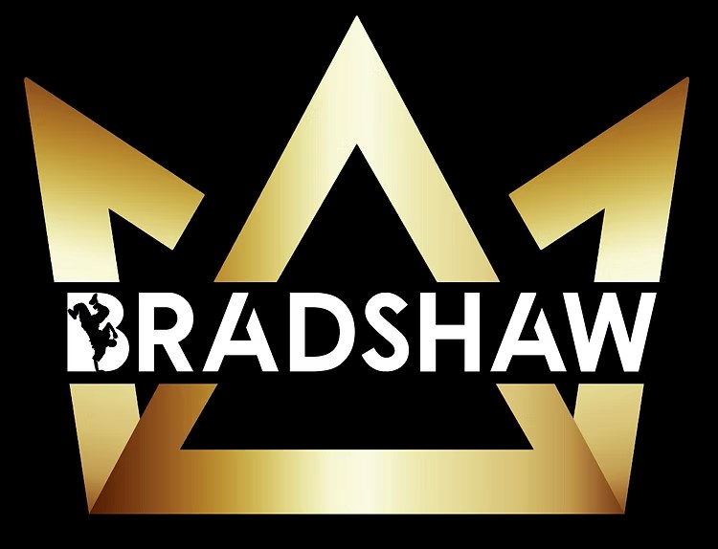

Child Safe
Code of Conduct
Title | Content
Commitment to child safety | Bradshaw Dance and Cheer have a zero tolerance to child abuse and neglect in any form.  We are committed to safeguarding and promoting the welfare of Children by providing a safe and inclusive.  All Children have the right to feel safe and protected from all forms of abuse, harm and neglect. Children have the right to take part in our sport in a safe, positive, and enjoyable environment.  To help keep children safe, we must create, maintain and improve our child safe reporting practices to ensure they remain effective. Everyone in our organisation must:  - know what to report, who to report it to and how to report it  - report any concerns about the safety or welfare of a child or young person immediately  - feel confident that concerns and allegations will be dealt with honestly and fairly  - feel confident in reporting unacceptable behaviour around children and young people  - Ensure the safety and wellbeing of the child is paramount when an allegation is made.  Types of Child Abuse include  Psychological abuse  Physical abuse  Sexual abuse  Grooming  Misconduct  Lack of appropriate care
I will | - Adhere to relevant Australian and NSW legislation, peak body requirements, and your Bradshaw Dance and Cheer values, child safe policies and other organisational and employment policies (including those that cover discrimination, bullying and harassment).  - Act with integrity by raising concerns with management if risks to child safety are identified anywhere withing Bradshaw Dance and Cheer  - Report and act on any complaints or concerns around behaviour or observed breaches of the Child Safe Code of Conduct. Reporting any concern, allegation, disclosure or witnessing of child abuse to the relevant person or authority.  - Take all reasonable steps to protect children from abuse (such as completing all induction and compulsory training and working in an open and transparent way).  - Respect the privacy of children and their families by keeping all information regarding child protection concerns confidential, and only discussing information with the relevant people, following Bradshaw Dance and Cheer’s reporting procedures as described in the Child Safe Reporting Policy.  - Treat all children and young people with respect, regardless of race, colour, sex, gender identity, sexual orientation, language, religion, political or other opinion, health status, national, ethnic or social origin, culture, property, ability or other status.  - Report any conflicts of interest (such as an outside relationship with a child, babysitting arrangements or any other formal or informal relationships with a child that exist outside your organisational setting).  - Listen to and value children and young people’s ideas and opinions.  - Actively promote cultural safety and inclusion.  - Welcome all children and their families and carers by being inclusive.  - Listen to children and responding to them appropriately.  - Working with children in an open and transparent way (so other adults always know what work I am doing with children).  - Dress in clean, appropriate clothing and following any dress code standards or guidelines (avoiding clothing that is revealing or that includes offensive language or pictures).  - Work within a team, despite any differences, to ensure the needs of the child (and their family) remain the paramount focus.  - Assist to develop Cheerleading or dance skills or techniques.  - Treat any injury with care and respect and take every possible precaution to prevent an injury
I won’t | - Participate in any unwarranted or unwanted touching with hands, other body parts or objects.  - Inflict any Corporal punishment, such as smacking or other forms of physical discipline.  - Initiate, permit or request unacceptable physical contact with a child or young person, such as massages or kisses.  - Facilitate situations that unnecessarily result in close physical contact with a child or young person, such as wrestling or tickling.  - Undertake a task of a personal nature for a child if they can do it for themselves, such as dressing, feeding, personal grooming or toileting.  - Pressure a child to have unnecessary physical contact  - Disrespect one another  - Use offensive language – swearing, using racial, cultural, homophobic or sexist slurs.  - Be abusive or intimidating – yelling, moving into another person’s personal space, finger pointing, talking over the top of others.  - Passive aggressive – purposely ignoring, isolating or dismissing others.  - Bully  - Make physical or psychological threats to harm another person.  - Use a computer, mobile phone, camera or other device in a way that is inconsistent with Bradshaw Dance and Cheer’s Child Safe Policy or other relevant policies.  - Communicate (including online) with a child about romantic, intimate or sexual feelings.  - Engage in unauthorised contact with a child online for the purpose of developing a sexual relationship.  - Make Sexual comments, converse or communicate with a child online.  - Use a computer, mobile phone, camera or other device to exploit or harass a child.  - Use a camera to record a child while they are dressing, bathing or using the bathroom.  - Use private text messages to communicate with a child where open communication is possible  - Provide children with alcohol, drugs, tobacco or pornography.  - Work or attempt to work while intoxicated or under the influence of illegal drugs.  - Drink alcohol, take illicit drugs, possess or distribute pornography while working with children (including on trips, excursions or any other offsite work).  - Take explicit photographs of children.  - Show children pictures, animations, images or websites of an inappropriate or adult nature.  - Discuss with children, topics of an adult or sexualised nature, including telling adult jokes  - Giving a child gifts, food, money, attention or affection in exchange for sexual activities or images.  - Be alone with a child when there is no professional reason for doing so.
Concerning behaviours | - Having conversations about hurting a child with other adults.  - Showing favour to one child over others.  - An adult asking a child to keep a secret, including a relationship with an adult.  - Babysitting, mentoring and/or tutoring a child out of work hours (without managerial approval for this kind of secondary employment)
Internal and external reporting obligations | All staff, volunteers, families and community members are encouraged to speak up if they have concerns about the safety of children.  Complaints about a breach of this Child Safe Code of Conduct must be reported to our Child Safe Officer, Coralie Byrnes. Coralie can be contacted on 0412 457 232 or at Coraliebradshaw@hotmail.com.  Some breaches of this code of conduct may need to be reported to NSW Police, the Department of Communities and Justice and the Office of the Children’s Guardian.  Our Child Safe Reporting Policy provides more information about our reporting obligations to external authorities and describes protections and confidentiality provisions for anyone making a report.  You can ask for the policy at the front desk. It is also available on our website: https://www.bradshawdanceandcheer.com.au/  Staff and volunteers who breach our Child Safe Code of Conduct may also be subject to disciplinary action. This can include increased supervision, appointment to a different role, suspension or termination from the organisation.
Criminal offences for not acting to protect children | An adult in child-related work in an organisation will commit an offence if they know another adult there poses a serious risk of abusing a child (under 18 years), and they have the power to reduce or remove the risk, and they negligently fail to do so. (Section 43B of the Crimes Act 1900)  All adults in NSW are required to report information to police if they know, believe or reasonably ought to know that a child (under 18 years) has been abused. (Section 316A of the Crimes Act 1900)
Name of person who has read and agreed to abide by the terms of this Child Safe Code of Conduct

Signature

Date reviewed
Next review date | 31/01/2026
Signature of responsible officer | Coralie Byrnes

